PhishGuard
HACK-O-WEEK | WEEK 5-6
JavaScript Fundamentals

Section 1: Title
Hack-O-Week • Week 5-6 • JavaScript Fundamentals. This report connects the college assignment to the inspected PhishGuard source code.

Section 2: Objective
Trace JavaScript values, functions, modules, and collection operations through PhishGuard input handling, API calls, and scan history.

Section 3: Theory
Bindings and functions. const prevents rebinding a variable; let allows reassignment. Arrow functions provide concise callbacks and lexical this. Template literals interpolate values into strings.
Objects and modules. Destructuring extracts fields from arrays or objects. Spread copies or extends iterable/object values; rest gathers remaining arguments or fields. ES modules use import and export.
Array methods. map transforms each item; filter keeps matching items; reduce combines items into one value; find returns the first match; some checks whether any match; every checks whether all match.

Section 4: Implementation in PhishGuard
The browser code is JavaScript in ES modules using React JSX. URLScanner manages input and scan-result state, calls the API service, then sends a result to history.js. ScanHistory filters records with filter and memoizes the derived list. JSX uses map to render repeated entries and details. reduce, find, some, and every are not used in current application code; short URL-history examples in the companion code file are explicitly educational.

Section 5: Code Explanation
handleSubmit and async analysis
Source: frontend/src/components/URLScanner.jsx
Actual implementation. The handler prevents a page reload, then asynchronous API output updates React state and scan history. The corresponding code is in this week’s companion Code_Examples.md file.
addToHistory
Source: frontend/src/services/history.js
Actual implementation. Object properties form a record; array spread places the newest record first, and slice caps stored history at 50 entries. The corresponding code is in this week’s companion Code_Examples.md file.
filteredHistory
Source: frontend/src/components/ScanHistory.jsx
Actual implementation. The template literal combines searchable fields; filter selects matches, and map turns each record into a table row. The corresponding code is in this week’s companion Code_Examples.md file.
Array methods, destructuring, and rest
Source: Educational example (not in PhishGuard)
Educational example. The rest pattern gathers olderScans after destructuring the latest item. reduce, find, some, and every answer different questions about a collection. These operations are not used in current PhishGuard code. The corresponding code is in this week’s companion Code_Examples.md file.

Section 6: Working Flow
- The form submit handler reads the controlled URL value.
- URLScanner validates it, then awaits analyzeUrl from the API module.
- The returned object updates result state and is passed to addToHistory.
- ScanHistory filters records and maps them into table rows.

Section 7: Learning Outcome
JavaScript functions and ES modules connect browser events to API data. Array methods provide focused transformations for rendering and searching scan records.

Section 8: Code Implementation Screenshots
Captured from the project source file open in Visual Studio Code. Captions identify the displayed file. Code examples are in the companion Code_Examples.md file, not in this Word report. Educational examples there are labeled and are not application code.
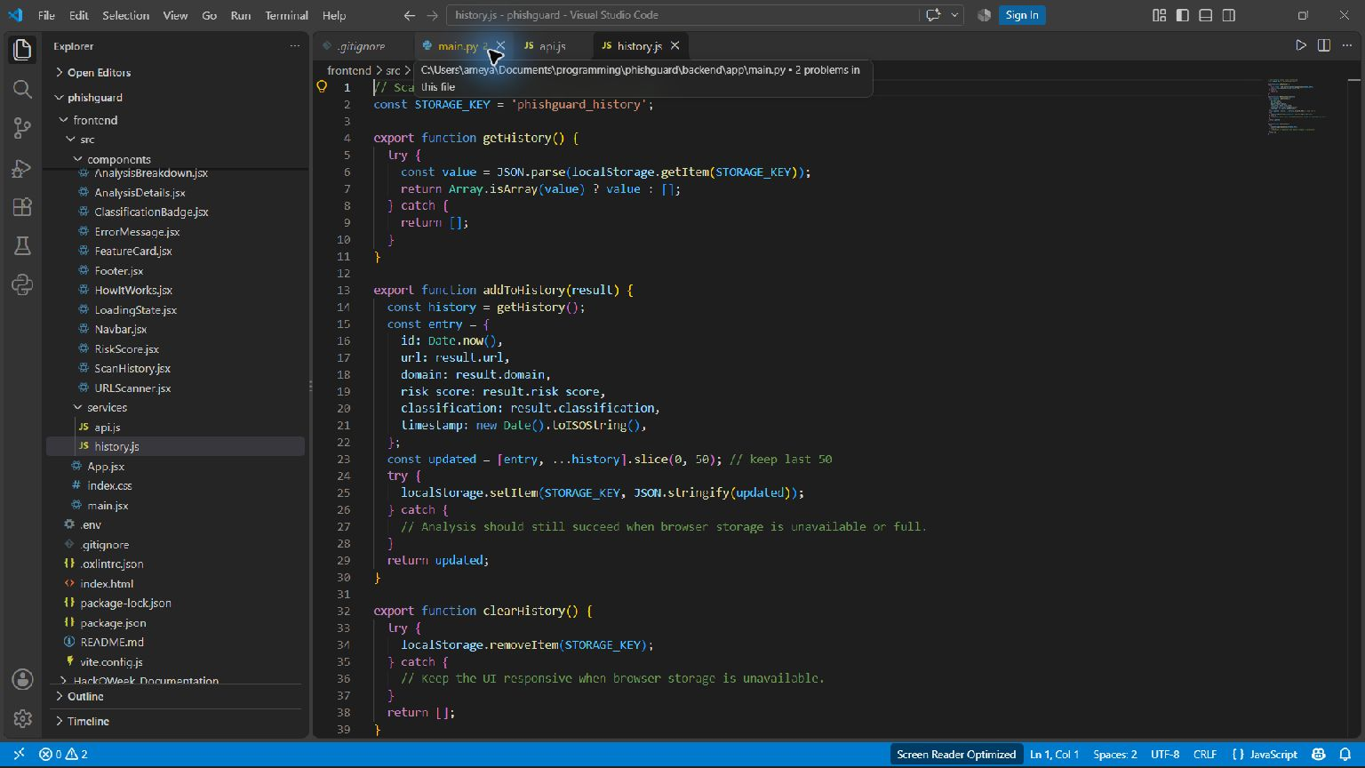
ES module and scan history object/array operations — frontend/src/services/history.js
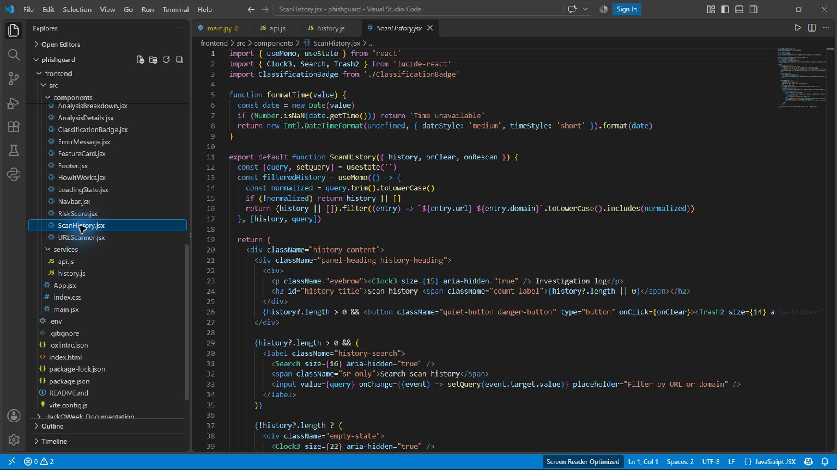
Scan history filter and map operations — frontend/src/components/ScanHistory.jsx

